Technical Report

For

Smart Irrigation System (SIS)
Prepared by
Group Name: Group 2
REGISTRATION NUMBER | STUDENT NUMBER | NAME
24/U/05727/EVE | 2400705727 | Kewoda Joanitah
24/U/22603/PS | 2400722603 | Aturinzire Hargreave
24/U/03072/PS | 2400703072 | Akankunda Rita
24/U/24837/PS | 2400724837 | Wagabaza David
24/U/10032/PS | 2400710032 | Ndagire Nairah

Mentor: | Mr. Paddy Asimwe
Course: | CSC 1304 Practical Skills Development
Date: | 28th July 2025

Contents
Contents ii
Abstract iii
1 Introduction (max. 2 pages) 1
1.1 User Challenge 1
1.2 Project Goals 1
1.3 Functional Requirements 1
2 Project Results (max. 3 pages) 2
2.1 Product Design 2
2.2 Product Functionality and Screenshots 2
3 Limitations and Next Steps (max. 1 page) 3
3.1 Limitations 3
3.2 Next Steps 3
References 3
4 Appendix A – Project Work plan 4
Appendix B – Contribution by Team Members 5

Abstract

Traditional irrigation methods often rely on guesswork, leading to water wastage and inconsistent crop growth. This project solves that problem by introducing a Smart Irrigation System that uses real-time soil moisture data to control watering automatically, ensuring crops get exactly what they need.
The system uses a microcontroller (Arduino Mega) connected to NPK sensor and a water pump. When the soil becomes too dry, irrigation is triggered automatically and stops when the optimal level is reached. What makes this system even more powerful is its web-based monitoring feature: data from the sensors is sent to a website, allowing users to monitor soil conditions, system status, and irrigation activity remotely in real time.
This project promotes smart farming by combining automation and digital monitoring, helping farmers save water, improve crop yields, and manage irrigation more efficiently.

Introduction
This document outlines the design, objectives, and requirements of a Smart Irrigation System. It provides a clear understanding of the user challenge being addressed, the goals of the project, and the functional requirements needed to build and operate the system. The aim is to present a practical, innovative solution that leverages automation and web technologies to improve irrigation practices for farmers and agricultural communities.

User Challenge
In many rural and urban farming communities, irrigation is still done manually or on a fixed schedule, regardless of actual soil conditions. This results in either overwatering or underwatering, leading to reduced crop yields, soil degradation, and unnecessary water consumption. These challenges are especially serious in regions with limited access to
water or where farmers are unable to monitor their farms regularly.
The lack of real-time feedback and automation in traditional irrigation systems creates inefficiencies and increases labor demands. For small-scale farmers and agricultural startups, these issues can lead to significant losses. There is a need for a smart, affordable, and easily accessible solution that helps farmers irrigate based on actual data — improving productivity while conserving water.

Project Goals.
This project aims to build a Smart Irrigation System that automatically waters crops based on soil moisture levels and allows real-time monitoring via a website. The system uses sensors to read soil moisture, a microcontroller (such as Arduino Mega ) to process the data, and a water pump to irrigate the crops when needed. All sensor data is transmitted to a web interface, where users can monitor soil conditions and system status remotely.
The goal is to provide an automated, low-cost, and user-friendly solution that addresses water waste and poor irrigation practices. By combining automation and IoT (Internet of Things) technology, the system ensures efficient water usage, reduces labor, and gives farmers better control over their irrigation process — even from remote locations. This innovation empowers farmers to make data-driven decisions, especially in resource-limited settings.

Functional Requirements

1.3.1 Sensor Monitoring and Data Collection
This part of the system is responsible for checking the condition of the soil.
What it does:
- Reads data from the following sensors:
  - Soil moisture
  - pH level
  - Nitrogen (N)
  - Phosphorus (P)
  - Potassium (K)
  - Electrical Conductivity (EC)
- Converts raw sensor data into readable values.
- Shows the sensor readings on the serial monitor for testing and debugging.

1.3.2 Automatic Irrigation Control
This part handles watering the plants.
What it does:
- Turns the water pump ON when soil moisture is too low.
- Turns the water pump OFF when there is enough moisture.
- On the first run, it forces the pump ON to make sure the system works.

1.3.4 Sending Data to Website
This part sends sensor data to a website using GSM (a SIM card).
What it does:
- Collects all sensor readings and forms a URL link with them.
- Sends the link to the web server using GSM commands.
- Sends this data every cycle for remote monitoring.

1.3.5 Website Monitoring
This part helps the user see the data online.
What it does:
- Shows all sensor readings (moisture, pH, N, P, K, EC, TDS) on a website.
- Allows users to check if the water pump and fertilizer are ON or OFF.

1.3.6 Smart System Behavior
This part controls how the system behaves overall.
What it does:
- Keeps running in a loop to check sensors and act automatically.
- Uses rules and limits (e.g., moisture == 30) to make decisions.
- Keeps working even if data fails to send to the website.

Project Results

Product Design
NPK Sensor

Microcontroller(arduino mega)
Power supply unit

Power supply

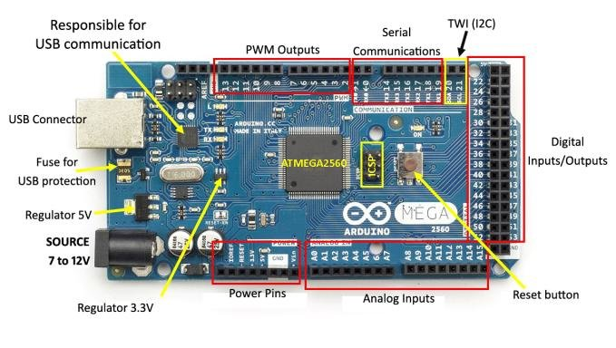

12volts battery

Relay circuit

Moisture sensor
Water pump unit
GSM module

USER INTERFACE UNIT

Phone
PC
Cloud
Agroset web interface



System architecture
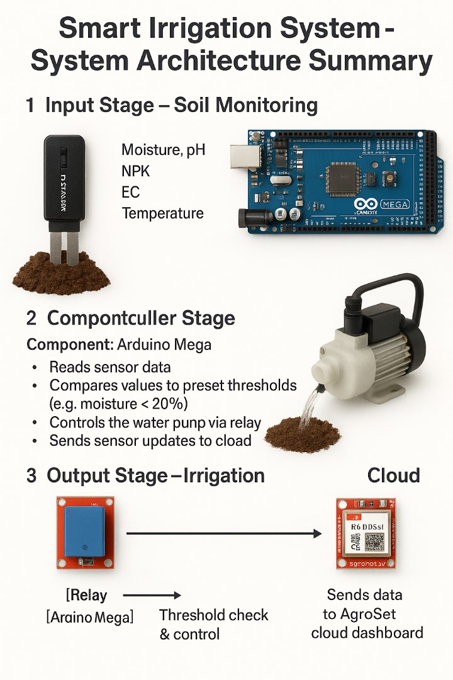

OUTPUT
Sends data to web

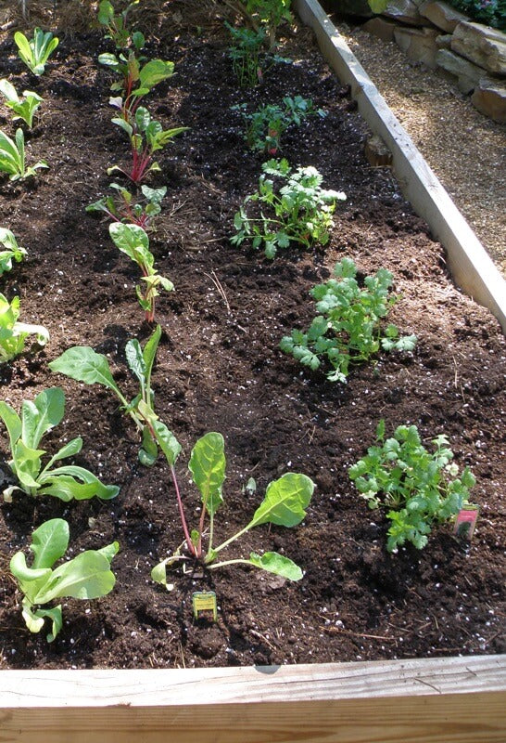
INPUT
Web interface(agroset)
Sends data to Arduino

Relay module
Microcontroller
(Arduino mega)

triggers the relay
Turns the pump on and off
Measures soil water levels

Water pump

Irrigates the soil

Product Functionality and Screenshots
<TODO: Provide at least description of the functionality of your software application under appropriate categories. For each functionality provide relevant screenshots.
"Solar-Powered System"
The smart irrigation system is powered using a solar panel, making it energy-efficient.
"Arduino Circuit Setup"
The Arduino Mega is connected to sensors and the relay module to control the system.

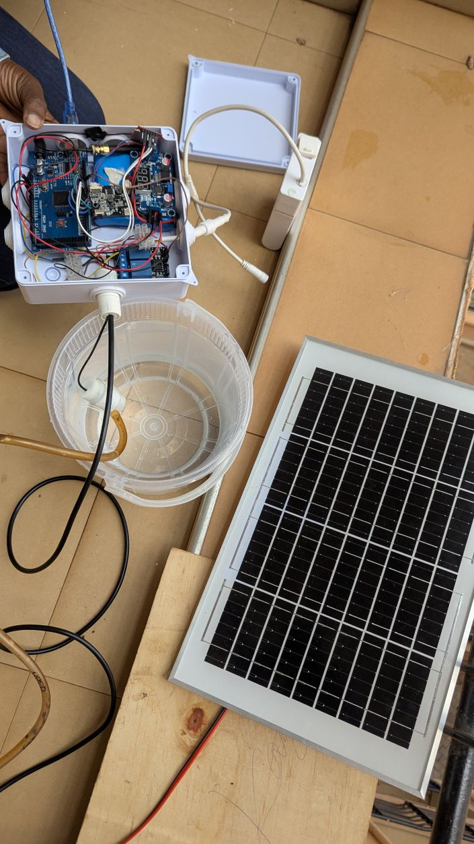

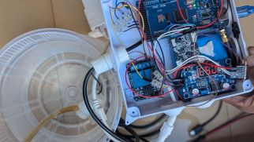

"Irrigating the Soil"
The system automatically irrigates the soil when moisture levels are low.
"Soil Moisture Sensor In Use"
A soil moisture sensor is inserted into the soil to monitor water levels.

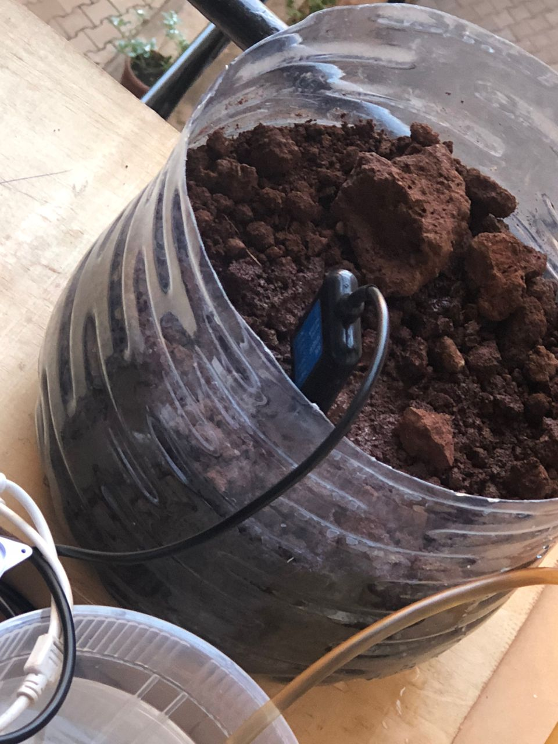

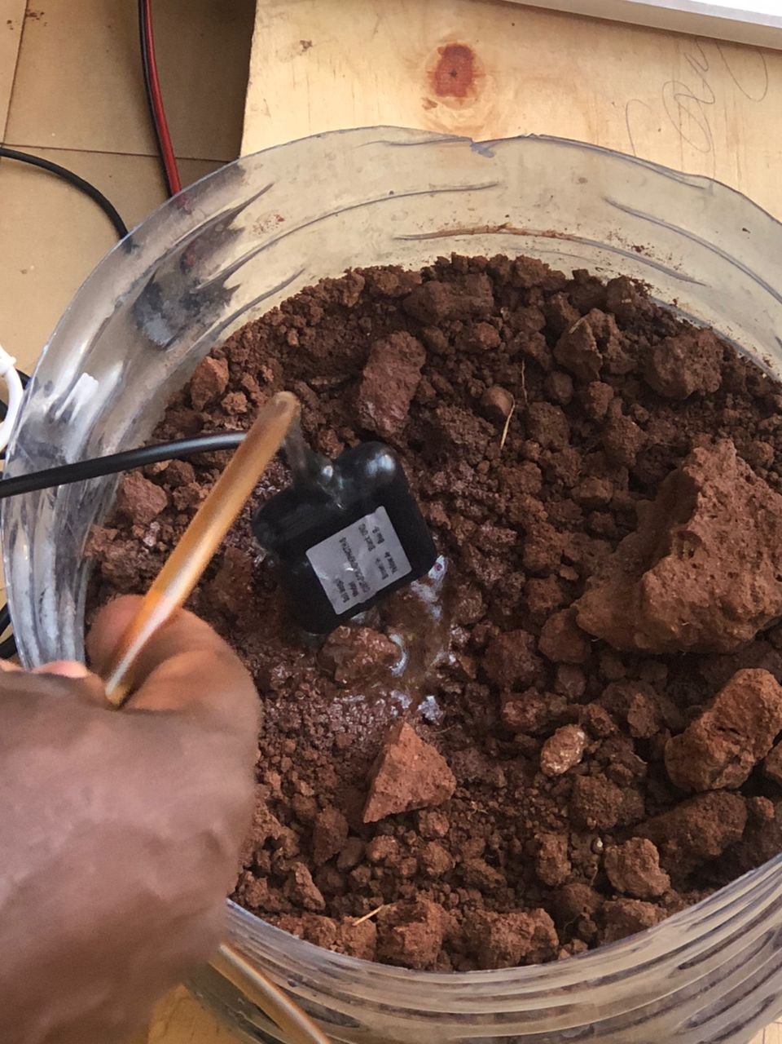

Project website and repository
Project website : https://agroset.us/

Github repository: https://github.com/ndagirenairah/SMART-IRRIGATION-AND-FERTILISER-SYSTEM

Limitations and Next Steps

Limitations
• The sensors sometimes give inaccurate readings and need regular adjustment.
• You can only watch what the system is doing on the website, but you can’t control it remotely yet.
• The GSM network used to send data might not work well in areas with poor signal.
• The system works best for small farms and may not handle big farms or many areas easily.
• The watering and fertilizer levels are fixed and cannot change automatically based on different crops or weather.

Next Steps
- Add a feature to let users turn the water and fertilizer pumps ON or OFF from the website.
- Make the sensors easier to adjust and more accurate.
- Add other ways to send data, like Wi-Fi, to improve connection.
- Upgrade the system to water different parts of a farm separately.
- Use smart methods to change watering and fertilizing based on weather and past data.
- Create a mobile app so farmers can get updates and control the system from their phones.

References
[1] Arduino, “Soil Moisture Sensor Tutorial,” Arduino Official Documentation. [Online]. Available: https://docs.arduino.cc/built-in-examples/sensors/SoilMoistureSensor/ [Accessed: 21-Jul-2025].
[2] Programming Electronics Academy, “How to Use a Soil Moisture Sensor with Arduino,” YouTube, Feb. 2022. [Online]. Available: https://www.youtube.com/watch?v=KpF7mUo0i6A [Accessed: 21-Jul-2025].
[3] Random Nerd Tutorials, “Guide for Soil Moisture Sensor with Arduino,” RandomNerdTutorials.com, 2023. [Online]. Available: https://randomnerdtutorials.com/guide-for-soil-moisture-sensor-arduino/ [Accessed: 21-Jul-2025].
[4] Circuit Digest, “Interfacing Soil Moisture Sensor with NodeMCU,” CircuitDigest.com, 2023. [Online]. Available: https://circuitdigest.com/microcontroller-projects/soil-moisture-sensor-with-nodemcu [Accessed: 21-Jul-2025].
[5] TutorialsPoint, “IoT Based Smart Irrigation System,” TutorialsPoint IoT Projects, 2024. [Online]. Available: https://www.tutorialspoint.com/iot-based-smart-irrigation-system [Accessed: 21-Jul-2025]

Appendix A – Project Work plan
The project was completed over the course of 6 weeks, divided into clear phases including research, hardware setup, coding, testing, and documentation. Below is the work plan represented in Gantt chart format.

Gantt Chart Table

Task/Week | Week 1 | Week 2 | Week 3 | Week 4 | Week 5 | Week 6
Research & Planning | ██████ | ██████
Component Collection |  | ██████
Hardware Setup |  | ██████ | ██████
Coding & Integration |  |  | ██████ | ██████
Web Monitoring Setup |  |  |  | ██████ | ██████
Testing & Debugging |  |  |  |  | ██████
Final Report Writing |  |  |  |  | ██████ | ██████
Presentation Prep |  |  |  |  |  | ██████

Each ██████ block represents the time spent on that task during the corresponding week.

Appendix B – Contribution by Team Members

No. | Team Member | Contribution
1. | Kewoda Joanitah | Helped set up and test the soil moisture sensors in the field and assisted in wiring and hardware connections.
2. | Aturinzire Hargreave | Focused on relay module control, circuit setup on the breadboard/PCB, and embedded code development for sensor logic.
3 | Akankunda Rita | Designed and developed the project website for monitoring, worked on cloud integration (API), and created user documentation.
4 | Wagabaza David | Managed battery connection and power supply setup, helped optimize energy usage for field hardware.
5 | Ndagire Nairah | Collected user feedback from students/farmers, helped write and edit the final project report, and supported research.

